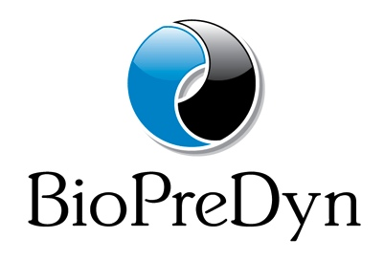

**BioPreDyn Workshop Funding**

**Application Form**

#### 

BioPreDyn will co-sponsor workshops organized by BioPreDyn partners, with up to 2,000 Euro.

To be eligible, the workshop should fall within the scope of BioPreDyn. Some of the places should be reserved for members from BioPreDyn partner labs.

Each application will be evaluated by the BioPreDyn partners. There is no deadline; applications will be considered as they are submitted, and the application period will be open as long as funding is available.

Please answer the following questions in enough detail to make it possible to critically evaluate your application.

*What are the workshop objectives?*

*Briefly explain the proposed structure of the workshop (outline of the agenda, invited speakers, hands-on or seminar format, etc):*

*What is the proposed number of participants, and how many of those spots will be reserved for BioPreDyn?*

*How else will the course be funded?*