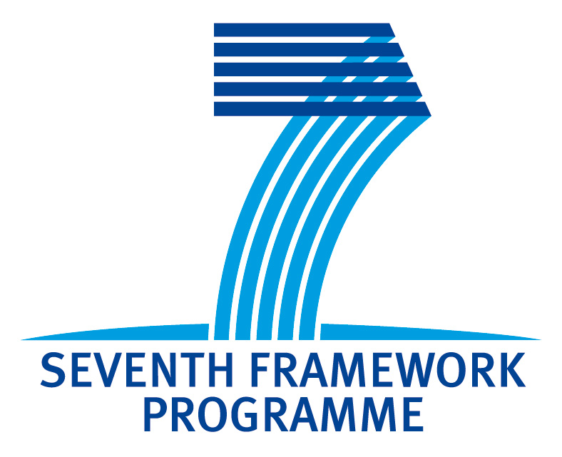

**BioPreDyn INTERIM REPORT**

**Grant Agreement number: FP7-KBBE-2011-5-289434**

**Project acronym: BioPreDyn**

**Project title:** From Data to Models: New Bioinformatics Methods and Tools for Data-Driven Predictive Dynamic Modeling in Biotechnological Applications

**Start date of project: 01.12.2011**

**End date: 01.12.2016**

**Interim report: 2st**

**Period covered:** from **01.04.2012** to **01.10.2012**

### Work package number:

**This interim report is a deliverable**

Core of the report for the period: Project objectives, work progress, and achievements

### I. Work progress and achievements during the period

Please provide a concise overview of the progress of the work in line with the structure of Annex I to the Grant Agreement:

1. A summary of progress towards objectives and details for each task of the work package;
2. clearly highlight significant results;
3. if you have had deviations from Annex I, explain the reasons for them and how this has impacted other tasks and/or available resources and planning;
4. if applicable, explain the reasons for failing to achieve critical objectives and/or not being on schedule, and explain the impact on other tasks as well as on available resources and planning;
5. have you have hired people for the project as planned? Explain any deviations between actual and planned actions;
6. if applicable, propose corrective actions.

**II. Partner/project dissemination**

1. Meetings attended by WP members since 01/04/2012
2. Presentations that acknowledged BioPreDyn at open

conferences/workshops since 01/04/2012

1. Submission of publications that acknowledge BioPreDyn

since 01/04/2012

**Work package overview:**

**WP1**. Database Integration & Exploitation. WP leader: di Bernardo; Partners: Saez-Rodriguez, Jaeger, Kaandorp, Mendes, Lawrence, Boix

**WP2**. Visualisation Tools for Data & Model Building. WP leader: Lawrence; Partners: Saez-Rodriguez, Jaeger, Lawrence, Boix, Kaandorp, Rattray

**WP3**. Integrated Software Tools for the Modelling Cycle. WP leader: Banga; Partners: Jaeger, Saez-Rodriguez, Blom, di Bernardo, Mendes, Lawrence, Rattray, Boix, Kaandorp

**WP4**. Application: Large-scale Models of Microorganisms WP leader: Saez-Rodriguez; Partners: Banga, Blom, di Bernardo, Lawrence, Mattray, Mauch

**WP5**. Application: Signalling & Regulatory Networks in Cells WP leader: Saez-Rodriguez; Partners: Banga, Blom, di Bernardo, Lawrence, Mattray, Mauch

**WP6**. Application: Developmental Gene Regulatory Networks in Animals. WP leader: Kaandorp; Partners: Jaeger, Blom, Lawrence

**WP7**. Application: Biotechnological Production Processes. WP leader: Moullon; Partners: Banga, Blom, Mendes, Mauch, Mouillon

**WP8**. Dissemination, Exploitation & Training. WP leader: Boix; Partners: Jaeger, Banga