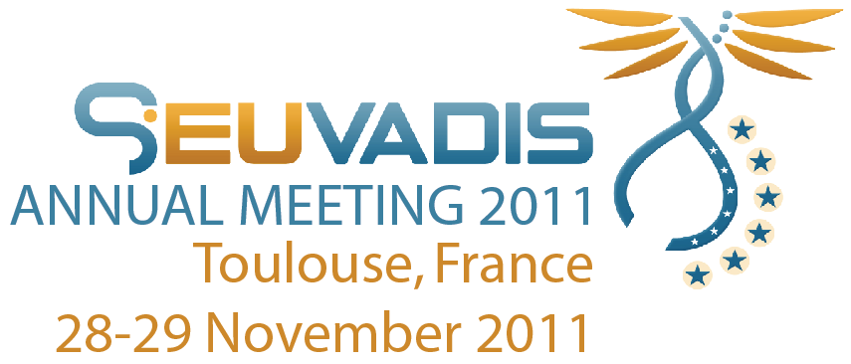

**ACTION POINTS**

**WP1: Coordination and Communication**

* IRDiRC - GEUVADIS will be involved in the EC-NIH coordination before projects are funded. Link with other initiatives (ENGAGE, ESGI, TECHGENE, etc.) to be enhanced
* Link with Illumina and Life Technologies (Spike-in controls, data compression with EBI) research activitiesto be enhanced on specific projects
* Potential link with OMIM to be defined. OMIM will pay attention to GEUVADIS genetic findings
* Partners should highlight GEUVADIS more in their genomics medicine publications, individual or collaborative

**WP2: Quality Control**

* Matthias (Uppsala) will reshape and simplify the survey he prepared and send it around to partners, and also to other projects members like ICGC partners that are part of GEUVADIS
* Recommendations from ENCODE and READNA to be explored
* Data collected before next year, and recommendations to be defined - 2013
* Terry will collect information on existing standardisation projects on sequencing technologies for diagnosis in the GEUVADIS participating countries

**WP3: Data storage**

* Submission of all GEUVADIS produced sequencing data to EGA
* Define a Data Access Committee
* All info on EGA already available on intranet (Natalja)

**WP4: RNAseq**

* HapMap samples project:
  + Deadline for submission of fastq files to EBI remains the same, Feb 15 2012
  + Tuuli will try to push Illumina to send the kits asap
  + If kits delivery late, deadline will be adapted
* Data analysis plan defined by Tuuli, (link with 1KGP analysis group) working group registered on the mailing list. Wiki in place
* March: low level data processing, Oct. 2012: paper submission. Other projects for RNAseq: Chronic Inflammatory Disorders, Parkinson’s Disease brain samples

**WP5: Exome seq**

* Mental Retardation, Parkinson’s Disease, Chronic Inflammatory Disorders (possible participation of Uppsala and Geneva - with T-cells controls dataset) and Fibromyalgia projects to follow up
* Publication of general findings of GEUVADIS investigators exome data on incidental findings and other data that not relevant for the specific exome-seq projects
* Common GEUVADIS database of already generated data (estimated over 3,000 exomes) Tim (Munich) will coordinate

**WP6: ELSI**

* ELSI questionnaires analysis publication
* New questionnaire for clinicians: how do they decide to send the patient to get a genetic test
* GEUVADIS Informed Consent template form in place for ongoing and future projects
* DTC: write a position paper and initiate creation of an information platform for the General Public on how to use a DTC and interpret DTC results

**WP7: Dissemination and training**

Explore participation of Life technologies and Illumina to the different workshops.

New Meetings and workshops:

* Joris Veltman: September 15-18, 2012. Focused, very practical course on routines for variant detection and prioritization of potentially pathogenic
* Summer 2012: Course on RNAseq, Marc Sultan
* Next GEUVADIS annual meeting in Santiago de Compostela



